Human Research Protection Program Department (HRPPD)

Data and Materials Sharing Tip Sheet

May I share data/specimens without additional permission or agreements? NO

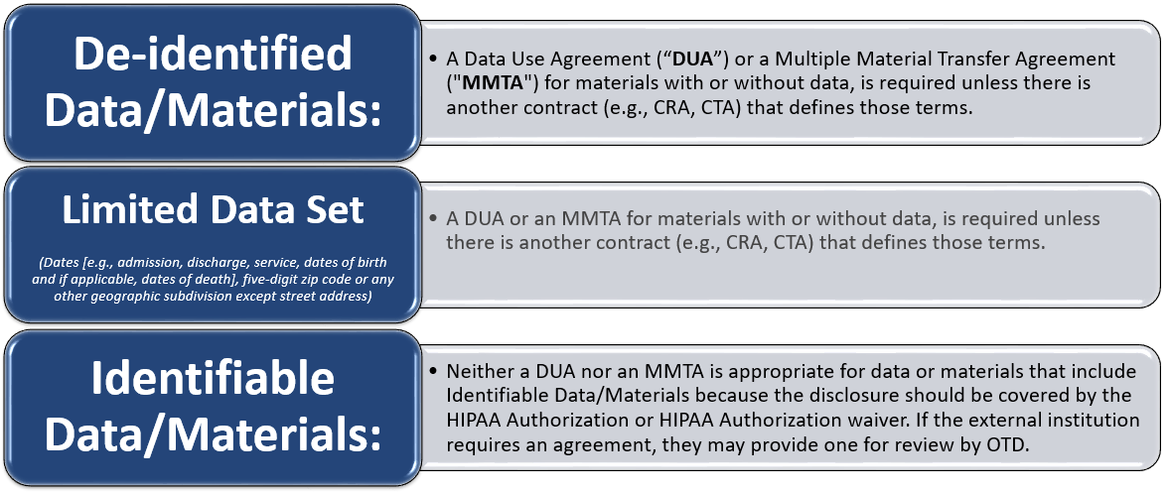

Table of Contents:

eAgreements
Who do I contact about my agreement?
eAgreements Commonly Request Changes by the HRPPD

eIRB:
Requirements in eIRB to share De-identified Data with or without Materials
Requirements in eIRB to share a Limited Data Set with or without Materials
Requirements in eIRB to share Identifiable Data with or without Materials
Disclosure Statements
Where do I add the Disclosure Statement?

UTSW Uses eAgreements to manage DUAs/MMTAs
eAgreements Link: https://eagreements.swmed.edu/eAgreements

Who do I contact about my agreement?
- The HRPPD processes DUAs where investigators are providing or providing and receiving data AND the UTSW agreement template will be used. When the external organization requires use of their agreement, the DUA will be transferred to the Investigator’s Department Liaison in the Office for Technology Development (OTD).

- OTD processes:
  - DUAs where human subject data will be received by investigators*
  - Collaborative Research Agreements (CRAs)*
  - Material Transfer Agreements (MTAs)*
  - Sponsored Research Agreements (SRAs)*
  - Confidential Disclosure Agreements (CDAs)
  - Visiting Scientist Agreements (VSAs)

*The HRPPD performs Ancillary Reviews for OTD when these agreements involve human subject data and/or specimens.

Find the agreement you need through the Contracts and Agreements Pathfinder (CAP), a tool that UT Southwestern created that allows users to work through a flowchart to accurately identify the appropriate system and agreement type for their research. Pathfinder (CAP) will connect with eAgreements for ease of access to appropriate forms to initiate an agreement. Employees can only access Pathfinder (CAP) through the intranet.

Return to Table of Contents

eAgreements Commonly Request Changes by the HRPPD

- Tab, “Agreement Upload”
  - Upload the agreement template from the external organization in Item 3.0 if UTSW will be receiving data.
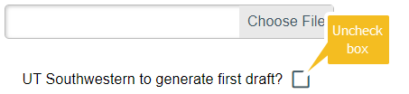

  - When UTSW is providing or providing and receiving data, the HRPP will use the UTSW agreement template unless the external organization requires their agreement (uploaded in Item 3.0) to be used and a statement that effect is added in Item 7.0:
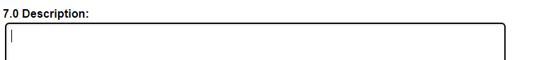
Example: The external organization requires that we use their agreement because this is a multi-site study, and all sites must sign the same agreement.

- Tab, “Agreement Upload”
- 6.0 Supporting documents: Upload the complete list of data points to be provided to the Contracting Party. *

*The data points will be reviewed to confirm data type (de-identified, limited data set, protected health information) and will be included or summarized in the agreement.
- De-identified: The data do not contain any of the 18 HIPAA Identifiers (names, telephone numbers, fax numbers, email addresses, social security numbers, medical record numbers, etc.).
- Limited Data Set: HIPAA identifiers are limited to dates (e.g., admission, discharge, service, dates of birth and if applicable, death), five-digit zip codes, and/or any other geographic subdivision except street address.
- Protected Health Information: The data include the 18 HIPAA identifiers beyond that of a limited data set.

  - 6.0 Supporting documents: Studies Relying on an External IRB: Submit the request to share data with an institution/entity to the External IRB in a modification and upload the approval letter in this section.
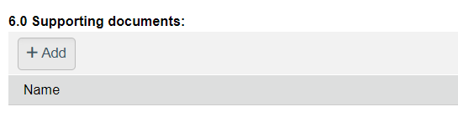

- Tab, “UTSW DUA Data Use Information”
- 2.0 Data Type: Although 2.0 says, “Select all that apply,” select the most appropriate response instead:
- De-identified: The data do not contain any of the 18 HIPAA Identifiers (names, telephone numbers, fax numbers, email addresses, social security numbers, medical record numbers, etc.).
- Limited Data Set: HIPAA identifiers are limited to dates (e.g., admission, discharge, service, dates of birth and if applicable, death), five-digit zip codes, and/or any other geographic subdivision except street address.
- Protected Health Information: The data include the 18 HIPAA identifiers beyond that of a limited data set.

  - 4.0 IRB Protocol Number: Note – This requirement applies to any Agreement where you are asked to supply an eIRB Study Number
- List the eIRB study number from/to which the data will be provided/received.

- If your research does not qualify as research that needs to be submitted in eIRB, check to see if it qualifies as one of the following instead:
- Non-Human Research (Y1 Form) – Submit if ALL data/specimens in the research will be anonymous to investigators AND study is not FDA regulated
- Non-Regulated Research (Y2 Form) - Submit for projects not intended as Research (Health surveillance, Routine Quality Improvement, Medical Quality Assurance, Program Evaluation, Academic Projects, Case Reports, etc.)
Complete the appropriate form and submit it to HRPP@UTSouthwestern.edu. When you receive the Determination Letter in Outlook, upload it in the “Agreement Upload” tab, Item 6.0: Supporting Documents.

- Tab, “UTSW DUA Data Use Information”
- 5.0 Concise scientific description of the use of the data: Describe how UTSW and/or the external organization are going to use the data being exchanged. Note: Unless the external organization is conducting the same study that is being done at UTSW, this description will not match the purpose of the study in eIRB.
    - List the external organization’s study number and study title so it can be listed on the agreement.

  - 6.0 How long will the data be used?
    - This will be used to determine the expiration of the agreement and may not be longer than 10 years. An amendment may be submitted to extend the term if needed.

Tab, “UTSW DUA Data Source Providing”
- 4.0 For data not collected at UT Southwestern, how was the data obtained:
  - Because the data was collected from UTSW according to Item 1.0, “Select where the data was originally collected,” select “Other” and type “Not applicable.”

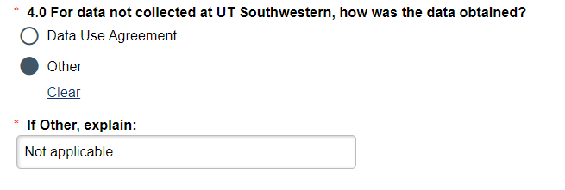
Return to Table of Contents

eIRB Requirements:
eIRB Link: https://eresearch.swmed.edu/eIRB

Requirements in eIRB to share De-identified Data with or without Materials:
You do not need to submit a modification in eIRB to share de-identified data/materials. The HRPP DUA Reviewer can add the information to eIRB for you. Complete the De-identified Disclosure Statement and send it to HRPP@UTSouthwestern.edu with the STU# and the DUA#. ​

Return to Table of Contents

Requirements in eIRB to share a Limited Data Set with or without Materials:
- Make sure the protocol and consent form allows for data sharing with external organizations. ​
- Complete the “Limited Data Set” Disclosure Statement and add it in a modification or smartform Item 24.1.1a if it is a new study. ​

Return to Table of Contents

Requirements in eIRB to share Identifiable Data with or without Materials:
- Participants must reconsent and authorize the transfer: The HIPAA Authorization needs to include the organization in the list to receive PHI as part of the study:

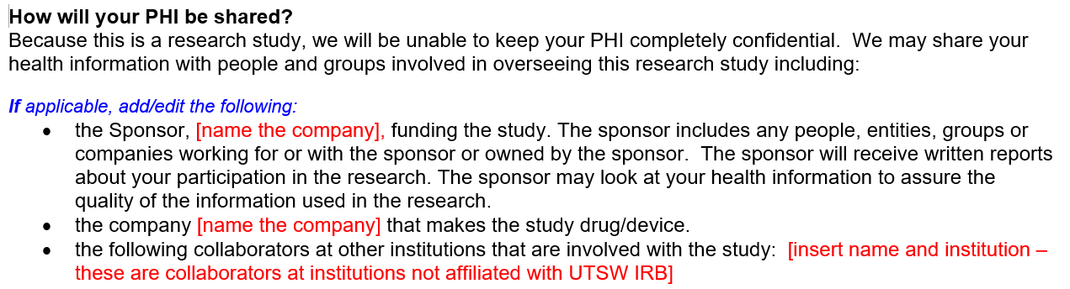
Consent and HIPAA Authorization Forms

OR

- The IRB must waive the disclosure in the HIPAA Authorization Waiver/Alteration (Form H):

  - Item 3e: HIPAA Waiver needs to allow for collection of PHI
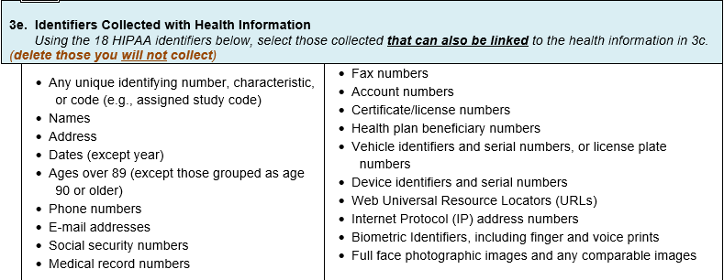

  - Item 4.c: HIPAA Waiver needs to allow for transfer of PHI:
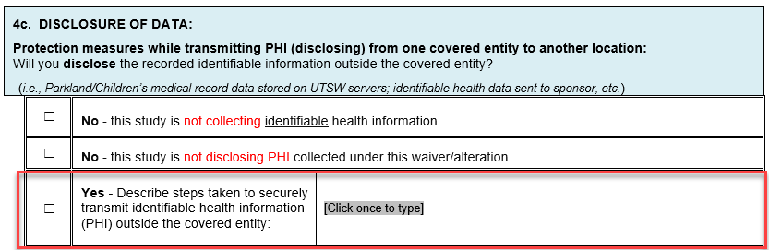

AND
- Complete the “Identifiable” Disclosure Statement and add it in a modification or to smartform Item 24.1.1a if it is a new study.

Return to Table of Contents

eIRB Requirements for Studies Relying on an External IRB:

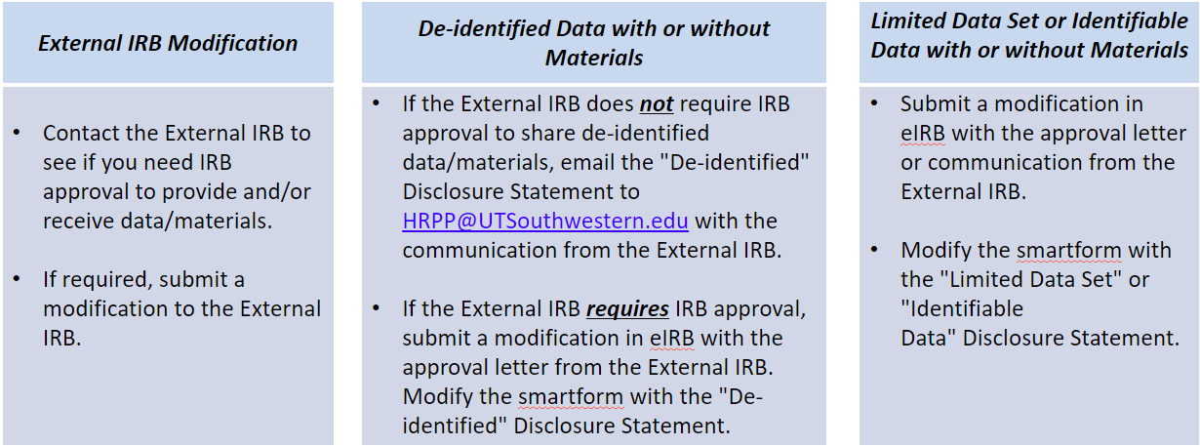

Return to Table of Contents

Disclosure Statements
Complete the appropriate Disclosure Statement.
​
De-identified Data with or without Materials – The HRPP DUA Reviewer may add this language to the approved eIRB study. Email it to HRPP@UTSouthwestern.edu.​
[A de-identified data set or A de-identified data set with materials or De-identified Materials] will be [provided to or received from or provided to and received from] [person at organization] under [Agreement #]. Include if data will be shared: The data will be [explain how the data will be transferred (e.g., made viewable by entering it in a REDCap database or transferred by sending it in an encrypted, password-protected Excel spreadsheet or some other method)].​
​
Limited Data with or without Materials – Submit a modification to the approved eIRB study or add this language to the new study in smartform Item 24.1.1a:
[A limited data set or A limited data set with materials] will be [provided to or received from or provided to and received from] [person at organization] under [Agreement #]. Include if data will be shared: The data will be [explain how the data will be transferred (e.g., made viewable by entering it in a REDCap database or transferred by sending it in an encrypted, password-protected Excel spreadsheet or some other method)].

Identifiable Data with or without Materials – Submit a modification to the approved eIRB study or add this language to the new study in smartform Item 24.1.1a:
[Identifiable data or Identifiable data with materials or Identifiable Materials] will be [provided to or received from or provided to and received from] [person at organization] under [Agreement #]. Include if data will be shared: The data will be [explain how the data will be transferred (e.g., made viewable by entering it in a REDCap database or transferred by sending it in an encrypted, password-protected Excel spreadsheet or some other method)].​

Return to Table of Contents

Where do I add Disclosure Statement?
eIRB Smartform
See the screenshots from eIRB for the appropriate smartform section to put the Disclosure Statement.

eIRB Smartform Item 24.0 (LITE: All Review Types) – Data and/or Materials
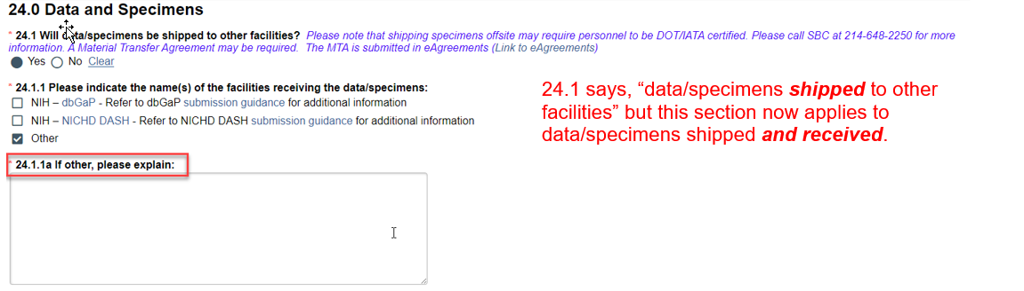

eIRB Smartform Item 46.6 (Legacy: Full Board and Expedited) – Materials with Data
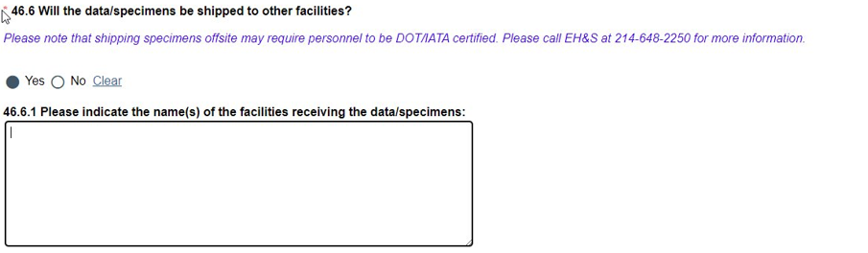

eIRB Smartform Item 63.3 (Legacy: Full Board, Expedited) – Data Only
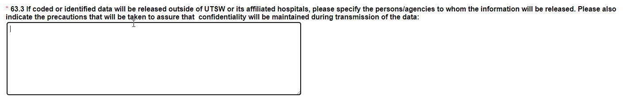

eIRB Smartform Item 17.5 (Legacy: Exempt) – Data and/or Materials
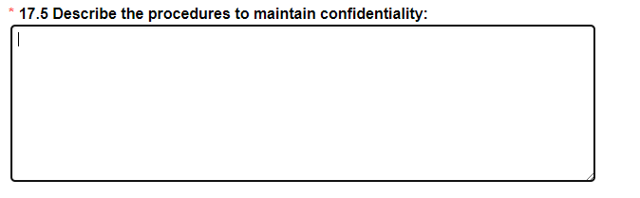

eIRB Smartform Item 19.2.2 (Legacy: Relying on an External IRB) – Data and/or Materials
Legacy Reliance studies do not have a place to note disclosures so add it in the modification and upload the Approval Letter or correspondence from the External IRB in smartform Item 19.2.2.​

Return to Table of Contents

